**SMART TRAFFIC MANAGEMENT**

**A MINI PROJECT REPORT**

***Submitted by***

**PRANITA.J.P (211422104344)**

***in partial fulfillment for the award of the degree of***

**BACHELOR OF ENGINEERING**

***in***

**COMPUTER SCIENCE AND ENGINEERING**



**PANIMALAR ENGINEERING COLLEGE**

**(An Autonomous Institution, Affiliated to Anna University, Chennai)**

**October 2024**

### **PANIMALAR ENGINEERING COLLEGE**

**(An Autonomous Institution, Affiliated to Anna University, Chennai)**

**BONAFIDE CERTIFICATE**

Certified that this project report **“SMART TRAFFIC MANAGEMENT”** is the bonafide work of **PRANITA.JP (211422104344)** who carried out the project work under my supervision.

**SIGNATURE SIGNATURE**

**Dr.L JABASHEELA,Ph.D., Dr.M.SHYAMALA DEVI. Ph.D.,**

**HEAD OF THE DEPARTMENT SUPERVISOR**

**PROFESSOR PROFESSOR**

DEPARTMENT OF CSE, DEPARTMENT OFCSE,

PANIMALAR ENGINEERING PANIMALAR ENGINEERING

COLLEGE, NASARATHPETTAI, COLLEGE, NASARATHPETTAI,

POONAMALLEE, POONAMALLEE,

CHENNAI-600 123. CHENNAI-600 123.

Certified that the above candidate(s) were examined in the Mini Project Viva-Voce Examination

held on...........................

**Internal Examiner External Examiner**

**ACKNOWLEDGEMENT**

We express our deep gratitude to our respected Secretary and Correspondent **Dr.P.CHINNADURAI, M.A., Ph.D.**for his kind words and enthusiastic motivation, which inspired us a lot in completing this project.

We would like to extend our heartfelt and sincere thanks to our Directors

**Tmt. C. VIJAYARAJESWARI, Dr. C . SAKTHIKUMAR, M.E., Ph.D.,** and

**Tmt. SARANYASREE SAKTHIKUMAR B.E., M.B.A.,** for providing us

with the necessary facilities for the completion of this project.

We also express our gratitude to our Principal **Dr.K.Mani, M.E., Ph.D.**for his timely concern and encouragement provided to us throughout the course.

We thank the HOD of t h e CSE Department, **Dr.L.JABASHEELA, Ph.D.,** for the support extended throughout the project.

We would like to thank my Project Guide **Dr.M.SHYAMALA DEVI. Ph.D.,**

and all the faculty members of the Department of CSE for their advice and suggestions for the successful completion of the project.

**PRANITA.JP (211422104344)**

## ABSTRACT

This case study addresses the issue of excessive traffic congestion and its impact on timely arrivals in urban areas. Traffic congestion is a significant problem that affects productivity, increases travel time, and contributes to environmental pollution. This study explores the causes of traffic congestion, the consequences on individuals and businesses, and proposes optimal solutions to alleviate traffic and ensure timely arrival.

The study employs a multi-faceted approach, including data analysis of traffic patterns, identification of peak congestion times, and evaluation of current traffic management strategies. Through this analysis, we highlight the most critical factors contributing to congestion, such as insufficient infrastructure, high vehicle density, and inadequate public transportation options.

Based on these findings, we propose a series of solutions aimed at reducing traffic congestion. These solutions include implementing intelligent traffic management systems, promoting the use of public transportation, encouraging carpooling, and developing infrastructure projects that enhance road capacity. Additionally, the study emphasizes the importance of policy changes and community engagement in achieving sustainable improvements in traffic flow.

Ultimately, this case study provides a comprehensive overview of traffic congestion issues and offers actionable solutions to improve traffic conditions, ensuring timely arrival for commuters and reducing the overall impact of traffic congestion on urban life.

**TABLE OF CONTENTS**

|  |  |  |
| --- | --- | --- |
| CHAPTER  NO | TITLE | PAGE NO. |
|  | ABSTRACT | i |
|  | TABLE OF CONTENTS | ii |
|  |  |  |
| 1. | **PROBLEM STATEMENT** | 01 |
| 2. | **SOLUTION STATEMENT** | 02 |
| 3. | **OBJECTIVE & GOALS** | 04 |
| 4. | TARGET AUDIENCE ANDUSER INTERVIEW QUESTIONS | 05 |
| 5. | **SURVEY INSIGHTS** | 06 |
| 6. | **EMPATHY MAPPING** | 07 |
| 7. | **FINDINGS** | 08 |
| 8. | **SOLUTIONS** | 09 |
| 9. | **ENHANCEMENT IDEAS** | 10 |
| 10. | **USER-CENTERED APPROACH** | 11 |
| 11. | **CARD SORTING** | 12 |
| 12. | **USER PERSONA** | 14 |
| 13. | **USER FLOW** | 15 |
| 14. | INFORMATION ARCHITECTURE | 16 |
| 15. | **FIDELITY WIREFRAMES** | 17 |
| 16. | **USER TESTING** | 18 |
| 17. | **CONCLUSION** | 19 |
|  |  |  |
|  |  |  |
|  |  |  |
|  |  |  |
|  |  |  |
|  |  |  |
|  |  |  |

**1.** **PROBLEM STATEMENT**

Urban areas face growing challenges due to severe traffic congestion, which negatively impacts various aspects of daily life. One of the most significant consequences is the frequent delay in arrivals, as both private and public transportation systems struggle to navigate the overcrowded roads. This issue affects not only individuals but also businesses, leading to reduced overall productivity as employees, goods, and services are consistently delayed.

Furthermore, traffic congestion contributes to increased stress and frustration among commuters, diminishing the quality of life in urban settings. The constant stop-and-go traffic also exacerbates fuel consumption, driving up costs for vehicle owners while simultaneously heightening levels of environmental pollution. Harmful emissions from vehicles, including carbon dioxide, nitrogen oxides, and particulate matter, have a lasting negative impact on air quality and public health. These pollutants contribute to climate change and increase the incidence of respiratory diseases among city dwellers.

The existing infrastructure and traffic management systems are ill-equipped to handle the rapidly rising number of vehicles. As urban populations grow and car ownership becomes more widespread, the road networks remain outdated, lacking the capacity to accommodate such density. Without significant improvements or adaptations to current systems, congestion is likely to worsen, creating even more inconvenience for commuters and further straining urban resources.

In response to these challenges, many cities are exploring innovative solutions, such as smart traffic management systems, public transportation upgrades, and the promotion of alternative modes of transportation like cycling and walking. However, addressing the root causes of urban traffic congestion requires a comprehensive and long-term strategy, involving cooperation between city planners, policymakers, and citizens to create sustainable, efficient urban mobility solutions.

**2.** **SOLUTION STATEMENT**

Implementing intelligent traffic management systems, enhancing public transportation, and promoting alternative commuting methods can play a crucial role in alleviating traffic congestion, ultimately leading to significant improvements in urban mobility and quality of life.

**Intelligent Traffic Management Systems (ITMS)** offer real-time monitoring and adaptive control of traffic flow. These systems use technologies such as sensors, cameras, GPS, and artificial intelligence to analyze traffic patterns and adjust signals dynamically, reducing bottlenecks and ensuring smoother traffic movement. By optimizing traffic signal timings and rerouting vehicles away from congested areas, ITMS can significantly decrease delays and minimize the time spent on the road. Furthermore, these systems can provide real-time traffic updates and alternative route suggestions to commuters, allowing for better trip planning and reducing the likelihood of congestion. As a result, vehicles spend less time idling, reducing fuel consumption and lowering harmful emissions that contribute to environmental degradation.

**Enhancing public transportation** is another key measure for reducing traffic congestion. Expanding the capacity, reliability, and coverage of public transit systems, such as buses, trams, and trains, can encourage more people to shift away from private car use. Well-coordinated and frequent public transportation reduces the dependence on personal vehicles and alleviates road congestion, especially during peak hours. Additionally, the integration of digital payment systems and real-time tracking apps for public transport services can improve the user experience, making public transit more convenient and attractive. Modernizing public transport fleets to include electric or hybrid buses can also help reduce greenhouse gas emissions, contributing to a cleaner environment.

**Promoting alternative commuting methods** like walking, cycling, and carpooling can have a significant impact on traffic reduction. Developing dedicated cycling lanes, pedestrian-friendly infrastructure, and bike-sharing programs encourages people to choose healthier and more sustainable forms of transportation, particularly for short-distance trips. Carpooling, whether organized through workplace initiatives or ride-sharing apps, can also decrease the number of vehicles on the road, reducing congestion while lowering individual transportation costs.

The combined implementation of these strategies will not only ensure timely arrivals and greater efficiency in urban transportation systems but will also have a positive effect on economic productivity. Reducing travel delays means employees can arrive at work on time, logistics and supply chains can operate more efficiently, and businesses can better serve their customers.

Moreover, addressing traffic congestion through these initiatives will lead to a significant reduction in environmental impact. By lowering vehicle emissions and promoting greener transportation options, cities can mitigate their contribution to climate change and improve air quality, creating healthier, more livable urban environments for residents.

In summary, a comprehensive approach that integrates intelligent traffic management, enhances public transportation, and encourages alternative commuting options offers a sustainable solution to the growing problem of urban traffic congestion. These measures will not only improve daily commutes but also contribute to long-term economic and environmental well-being.

## 3.OBJECTIVE & GOALS

**Objective:**

To identify the root causes of traffic congestion and propose effective solutions.

**Goals:**

* + Reduce average commute time by 30%.
  + Increase public transportation usage by 20%.
  + Decrease vehicle emissions by 25%.
  + Improve overall commuter satisfaction.

## 4. TARGET AUDIENCE &

## USER INTERVIEW QUESTIONS

#### Target Audience

* Daily commuters (working professionals, students)
* Urban planners and traffic management authorities
* Public transportation providers

#### User Interview Questions

* How often do you experience traffic congestion during your commute?
* What are the main challenges you face due to traffic congestion?
* How does traffic congestion affect your daily schedule and productivity?
* What modes of transportation do you use, and why?
* Have you tried using public transportation or carpooling? Why or why not?
* What changes or improvements would make your commute more efficient?

## 5.SURVEY INSIGHTS

#### Survey Insights

* 70% of respondents experience traffic congestion daily.
* 60% report increased stress levels due to prolonged commute times.
* 40% use public transportation, citing reliability and coverage issues.
* 80% are open to using alternative commuting methods if they are convenient and reliable.

## 6 . EMPATHY MAPPING

**Feel:** Frustrated, stressed, anxious. **Think:** "Why is the traffic always so bad?" "Will I be late again?" **Do:** Look for alternative routes, consider leaving earlier. **Say:** "I hate being stuck in traffic." "Public transport is not reliable."

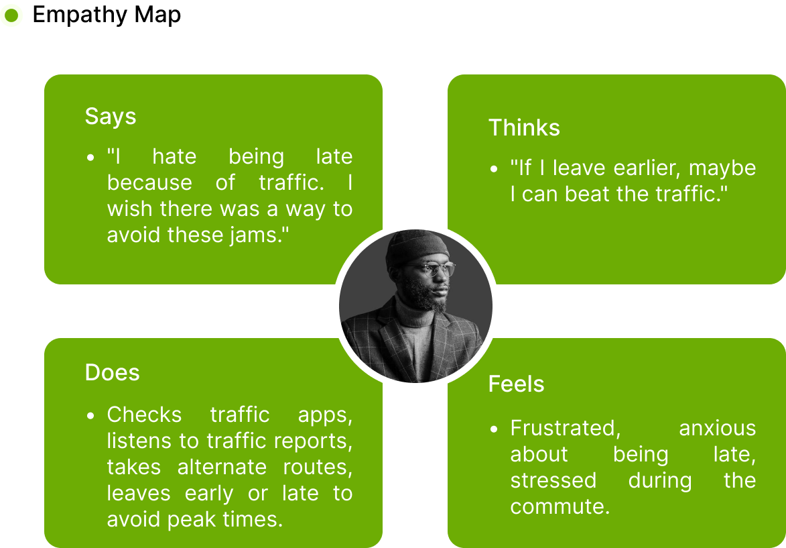

## 7. FINDINGS

* Insufficient road infrastructure to handle peak traffic.
* Lack of reliable and comprehensive public transportation options.
* Inefficient traffic management systems.
* Low adoption of alternative commuting methods like carpooling.

## 8. SOLUTIONS

* **Intelligent Traffic Management Systems:** Use AI and IoT to optimize traffic flow and reduce congestion.
* **Public Transportation Enhancement:** Improve the reliability, coverage, and frequency of public transport services.
* **Promotion of Carpooling and Ride-sharing:** Develop platforms and incentives to encourage carpooling.
* **Infrastructure Development:** Invest in expanding and modernizing road infrastructure.

## 9.ENHANCEMENT IDEAS

* Real-time traffic monitoring and prediction using AI.
* Integration of public transportation schedules with ride-sharing apps.
* Development of dedicated carpool lanes.
* Community-driven initiatives for carpooling.

## 10.USER-CENTERED APPROACH

Focus on understanding the commuters' needs and pain points through user research, interviews, and surveys. Develop solutions based on their feedback, ensuring the proposed changes directly address their issues and improve their commuting experience.

**Empathize**

* Conduct user interviews and surveys to understand pain points related to traffic.
* Analyze traffic data and gather insights on peak traffic times and common congestion areas.

**Define**

* Define the problem statement: "Commuters face significant delays due to unexpected heavy traffic, leading to stress and missed appointments."

**Ideate**

* Brainstorm solutions such as real-time traffic updates, alternative route suggestions, multi-modal transport options, and predictive traffic analysis.
* Conduct card sorting sessions to understand how users categorize and prioritize these features.

**Prototype**

* Develop low-fidelity wireframes to outline the basic layout and flow.
* Create high-fidelity prototypes incorporating user feedback for detailed design.

**Test**

* Conduct usability testing with the prototypes to gather user feedback.
* Perform A/B testing to compare different design solutions and refine the final product.

## 11.CARD SORTING

Conducting card sorting sessions with users is an effective method for understanding their preferences and mental models when it comes to traffic information, public transportation schedules, and commuting options. This user-centered approach helps designers create intuitive and user-friendly interfaces for traffic management apps and websites, ensuring the final product aligns with users' needs and expectations.

**Card sorting** is a technique in which participants are presented with a set of cards, each representing a different feature, function, or piece of information related to the app or website. Users are then asked to organize these cards into categories that make sense to them, either by grouping them into predefined categories (closed card sorting) or by creating their own categories (open card sorting). This process reveals how users naturally organize and prioritize information, providing valuable insights into how the app's interface should be structured.

When applied to the design of traffic management apps and websites, card sorting can help uncover how users think about essential features like:

1. **Traffic information**: Users might prefer real-time updates, predictive traffic patterns, or alternative route suggestions to be easily accessible. By sorting cards, users will indicate whether they value live data more than historical trends or accident alerts, helping designers prioritize these features in the app's layout. The insights from card sorting can inform the placement of navigation menus, map views, and filters for specific traffic updates.

2. **Public transportation schedules**: Understanding how users prefer to view transportation schedules—whether by time, route, proximity, or mode of transportation—helps in designing interfaces that are intuitive and efficient. For instance, users may want to quickly access next departure times, transfer points, or service disruptions. Card sorting can help determine how users categorize this information, making it easier for them to find what they need.

3. **Commuting options**: With the increasing demand for sustainable commuting, users may want easy access to alternatives like cycling routes, walking paths, or ride-sharing services. Card sorting can reveal whether users prefer to see all options together or categorized by mode of transport. It can also highlight how users compare travel time, cost, and environmental impact when choosing their preferred commuting method.

By engaging users directly through card sorting sessions, designers can identify which features are most important and how users expect to navigate through them. This method also uncovers potential usability issues early in the design process, allowing developers to make adjustments before finalizing the app or website. For example, if users frequently group traffic alerts and public transportation disruptions together, it may indicate a need to present this information in a combined view to improve usability.

Moreover, card sorting sessions encourage user engagement and ownership of the final product. Participants feel that their feedback is being valued, which enhances user satisfaction and adoption rates when the app or website is launched.

In conclusion, conducting card sorting sessions with users is an essential step in designing intuitive interfaces for traffic management apps and websites. By aligning the design with users' mental models and preferences for accessing traffic information, public transportation schedules, and commuting options, developers can create user-friendly, efficient platforms that meet the needs of modern commuters. This leads to better user experiences, higher engagement, and a more streamlined approach to navigating urban transportation challenges.

## 12.USER PERSONA

## 13.USER FLOW

1. **Real-Time Traffic Updates:** Views current traffic conditions.
2. **Route Planning:** Selects optimal route based on traffic data.
3. **Public Transport Integration:** Checks public transportation schedules.
4. **Alternative Options:** Explores carpooling or ride-sharing options.
5. **Commute:** Follows the suggested route or option for a smoother commute.

## 14.INFORMATION ARCHITECTURE

## 15.HIGH FIDELITY WIREFRAMES

* Design detailed interfaces with user-friendly navigation, real-time updates, and integrated commuting options.

## 16.USER TESTING & PROPOSED NEW IDEAS

#### User Testing

* Conduct usability testing sessions with target users to gather feedback on the wireframes.
* Iterate based on feedback to improve the design and functionality.

#### Proposed New Ideas

* **Smart Traffic Signals:** Adaptive traffic lights that adjust based on real-time traffic conditions.
* **Commuter Rewards Program:** Incentivize carpooling and public transport usage with rewards.
* **Mobile App Integration:** Seamless integration of traffic data, public transport, and ride-sharing in one app.

## 17. CONCLUSION

Addressing traffic congestion requires a **comprehensive, multi-faceted approach** that combines technology, infrastructure improvements, and user-centric solutions. Traffic congestion in urban areas is a complex issue influenced by factors such as rising vehicle density, inefficient traffic management, limited infrastructure, and the varied needs of commuters. To effectively tackle this problem, it's crucial to consider a wide range of strategies that not only optimize traffic flow but also improve the commuting experience for individuals and communities.

**Technology** plays a pivotal role in modern traffic management. Intelligent Traffic Management Systems (ITMS) leverage cutting-edge technologies such as sensors, cameras, GPS, and artificial intelligence to monitor traffic conditions in real time. These systems enable dynamic adjustments to traffic lights, route recommendations, and even predictive analytics to anticipate congestion before it happens. By optimizing traffic flow, such technologies reduce delays, minimize idling, and lower vehicle emissions, contributing to both timely arrivals and environmental sustainability. Additionally, mobile apps that provide real-time traffic updates, route alternatives, and public transport information empower users to make informed commuting decisions, helping them avoid congestion and reducing overall stress.

**Infrastructure improvements** are equally critical. Many cities struggle with outdated road networks that simply cannot support the increasing volume of vehicles. Expanding roads, building new overpasses or tunnels, and creating more efficient intersections can alleviate traffic bottlenecks. Moreover, dedicated lanes for buses, bicycles, and pedestrians encourage the use of alternative modes of transportation, further easing road congestion. Well-planned infrastructure that integrates public transit, walking, and cycling can create a more balanced and efficient urban transport system, reducing the reliance on personal vehicles. Investing in infrastructure improvements also means ensuring that public transportation is accessible, reliable, and appealing to a wide range of users, so that more people are encouraged to use it.

However, even the best technology and infrastructure can fall short without **user-centric solutions** that address the specific needs and pain points of commuters. Understanding commuter behavior is essential to designing solutions that resonate with users. For instance, many people opt to drive because public transportation is perceived as unreliable or inconvenient. By improving the reliability, frequency, and convenience of public transit options—while also providing accurate real-time schedules and clear information on service disruptions—commuters are more likely to shift from personal vehicles to public transportation, reducing traffic on the roads.

Additionally, solutions like carpooling, ride-sharing, and flexible work hours can be tailored to meet the preferences of commuters. Promoting the use of carpool apps or incentivizing businesses to adopt flexible work schedules can stagger peak traffic times, resulting in less congestion during rush hours. Similarly, encouraging alternative commuting methods, such as biking or walking, can help reduce the number of cars on the road, particularly for short-distance trips. These user-centric solutions prioritize commuter well-being by offering flexibility, convenience, and less stressful alternatives to sitting in traffic.

By combining **technology**, **infrastructure improvements**, and **user-centric approaches**, cities can develop **effective strategies** to mitigate traffic congestion and improve urban mobility. This comprehensive approach leads to **timely arrivals**, **reduced stress**, and **enhanced quality of life** for residents. It also contributes to broader environmental goals by reducing emissions, improving air quality, and promoting sustainable modes of transport.

In summary, addressing urban traffic congestion requires a holistic view that accounts for the interconnected nature of transportation systems. By focusing on technological advancements, improving infrastructure, and prioritizing the needs and preferences of commuters, cities can create transportation networks that are more efficient, sustainable, and user-friendly.